
North Bengal International University

Assignment: 1 04
Exp Name : A Data Structure Method to make a Smart Daily Planner

Subject : Data Structure
Subject Code : CSE 0612-2131

Submitted By:
Name : Md. Tanvir Rahman Pranto
Dept : CSE 26
Roll : 0712340012101005
Semester : 2nd Year, 4th semester.

Submitted To:
Name : Saifur Rahman
Designation : Lecturer
Dept : CSE
Date : 16-06-2025

✦ Scenario 5: Smart Daily Planner

🔹 Most Suitable Data Structure: Priority Queue

✦ Definition (Short)
A Priority Queue is a special type of queue in which each element is associated with a priority, and elements with higher priority are served before elements with lower priority.

✦ Flowchart
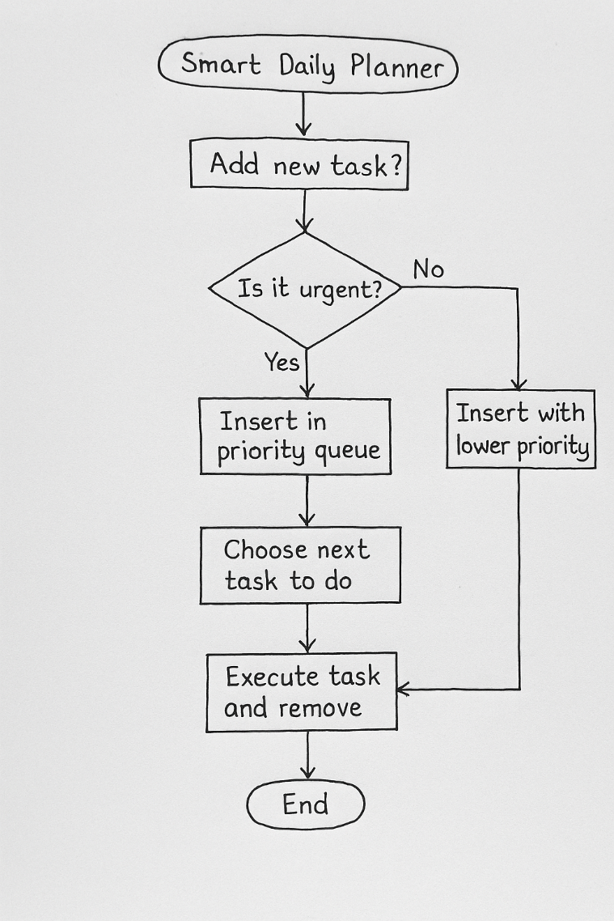

✦ Why It’s the Most Suitable
In a smart daily planner, tasks vary in urgency. Some need to be done immediately (like sudden assignments), while others can wait. A priority queue perfectly fits this use case by automatically ordering tasks based on importance. This way, I can always see the most important task on top without manually sorting everything again and again.

✦ How the Priority Queue Helps in Each Part of the Problem
Problem Feature | How Priority Queue Helps
Add tasks throughout the day | New tasks can be inserted into the queue with a defined priority.
Urgent tasks come first | Automatically moved to the front of the queue due to higher priority.
Remove or reschedule tasks | Tasks can be removed or reinserted with updated priorities as needed.
Decide what to do next | The task with the highest priority is always at the front, ready to execute.

✦ Personalized Answers to Scenario Questions

🔸 Q1: Pick 3 actual tasks you did today — how would you arrange them?
Today, I worked on:
- Submitted an online quiz (Urgent)
- Cleaned my email inbox (Normal)
- Downloaded class notes (Can wait)
Priority Queue Order:
- Submitted online quiz → Priority 3 (Highest)
- Clean email inbox → Priority 2
- Download class notes → Priority 1 (Lowest)

🔸 Q2: If you get a surprise task from your teacher, where do you place it?
If my teacher suddenly gives a surprise assignment — for example, “Send a summary of today’s class within 30 minutes,” I’ll:
- Immediately assign it the highest priority.
- Add it to the top of the priority queue so it gets completed next.
This avoids missing any urgent academic responsibilities.

🔸 Q3: How do you decide what to do next?
I simply check the top of the priority queue.
- The task with the highest priority value is always served first.
- If two tasks share the same priority, the one added earlier gets done first.
This keeps my schedule fair but still focused on what matters most.

✦ Final Summary
The priority queue is the best-suited data structure for managing a smart daily planner. It allows dynamic task addition, prioritizes urgent items, and helps organize my day efficiently. Whether tasks are rescheduled or inserted at the last minute, the queue ensures that I never lose sight of what needs attention first — making my time management smarter and stress-free

